F2 Unit 51 – PRESCRIPTION & IMPLEMENTATION GUIDE |  | WRITTEN and CERTIFIED BY: K. Zimlinghaus 7/28/2018
ENVIRONMENTAL ANALYSIS:  Forsythe II Project | DECISION DATE: 7/10/2017 | NEPA ACRES: 89  GIS ACRES: 79 | BASE FISCAL YEAR: 2018
EXISTING HSS: 3A-8%, 3B-17%, 4B-75%
DESIRED HSS: 1M-20%, 3A-15%, 3B-15%, 4A-35%, 4B-15%
COVER TYPE: Existing Overstory PP-43% DF-34%, Bare ground-18%  Desired Overstory PP-50%, DF-20%, Bare ground–30%, |  |  | EXISTING BASAL AREA = 66 sq ft/ac  DESIRED BASAL AREA = 35-40 sq ft/ac
Existing Condition
The unit is predominantly located on a north aspect with forested areas and a canopy cover between 1 to 80 percent. Ponderosa pine makes up about 43% of the overstory and Douglas-fir, 34%; the understory is comprised of about 16% ponderosa pine, 26% Douglas-fir, 2% aspen, 8% Rocky Mountain juniper, and 46% bare ground. The tree structure arrangement of conifers is diverse from sapling sized trees to conifers > 20” DBH. Approximately 35% of the unit area’s overstory is made up of conifers with diameters between 8” and 12” DBH. Dwarf mistletoe is present in ponderosa pine and has infected understory trees to varying levels. The spatial arrangement of conifers is varied as is the density across the unit. Unit density ranges from open, grass understory with light mixed overstory conditions to dense mixed conifer aggregations, generally on north aspects.

Desired Condition
The desired stand conditions would exhibit characteristics of an open ponderosa pine site lightly mixed with Douglas-fir where stand heterogeneity is diverse and sustainable over time. The majority of the unit will be grass dominated and fairly open with a mixture of moderately dense mixed conifer aggregations, generally on north aspects. Ponderosa pine would be the dominant species mixed with light concentrations of mixed conifer including Douglas-fir, aspen, and Rocky Mountain juniper. A combination of individual trees and groups will provide both horizontal and vertical stand structure in a mosaic pattern. Spatially, the tree arrangement would feature a resilient stand structure that is resistant to stand replacing natural disturbances. Dwarf mistletoe in ponderosa pine would be absent or present in light to moderate levels.

Objectives
- Reduce the severity and intensity of a wildfire within the WUI.
- Restore ponderosa pine/mixed conifer stands, structure, and spatial patterns in order to increase resistance and resiliency to future natural disturbance.
- Old growth tree component: retain ponderosa pine greater than 12” DBH or ponderosa pine greater than 10” DBH with flat top crowns and/or bark that is orange over 50% of the bole of the tree. Reduce ladder fuels beneath and around ponderosa pine >12” DBH.
- Emphasize grouped ponderosa pine spacing where conditions allow and individual spacing where conditions aren’t conducive or for other conifer species in order to meet the basal area reduction.

Note: This unit will be manually cut and the slash will be hand piled and burned.

ACTIVITY | TIME | AC | DESCRIPTION, MARKING GUIDES, MONITORING, ETC.
Ponderosa pine / Mixed Conifer Thin | 2018 | 57 | Cutting Guides  - Reduce the existing basal area by 40%-50%.  - Retain all conifers > 10” DBH except for dwarf mistletoe infested trees, see below.  - Species preference to retain: ponderosa pine > Douglas-fir > Rocky Mountain juniper.  - Retain the healthiest conifer (good vigor, at least 40% live crown ratio, insect/disease and damage free. regardless of size) and identified by the species preference.  - Retain healthy ponderosa pine saplings and poles (up to 5” DBH) located under the crowns of conifers (5” - 10” DBH), and cut overstory tree. If seedling/sapling/pole is not healthy, cut the smaller tree.  - Cut all dwarf mistletoe infested ponderosa pine < 12” DBH, Hawksworth Rating of 3+ (see description below).  - Group and retain ponderosa pine identified as at least 2 to 10 ponderosa pine trees > 10” DBH with touching or intermingled crowns, or at least 3 to 7 ponderosa pine trees 5”- 8” DBH with intermingled crowns. Cut all ladder fuel trees within the dripline of the identified group regardless of species.  - Space the groups of ponderosa pine 10’-20’ crown dripline to the adjacent crown dripline of individual or group of trees.  - In open areas (existing basal area < 15sq. ft/ac), cut all conifers, regardless of species up to 8”DBH while maintaining Rocky Mountain juniper guides, below.  - Cut ladder fuel conifers within and up to 5’ from the edge of the dripline on retained overstory trees.  - Where Rocky Mountain juniper occurs, leave an average of one large individual, or clump of three or more per acre if available. Cut all juniper that are within 25’ of the crown of retained trees.  - Do not cut aspen. In aspen clones (identified as the number of aspen trees with diameters > 1” DBH that are greater than the number of conifers within the clone perimeter) cut all ponderosa pine and Douglas-fir < 12” DBH or lodgepole pine < 12” DBH. Extend out 30 feet from the edge of an aspen clone perimeter (diameter >1” DBH) and cut all conifers < 12”DBH.  - Retain 5 of the largest snags (dead trees) per acre (minimum 8” DBH for lodgepole pine and 10” DBH for both ponderosa pine and Douglas-fir). If the minimum number of snags is not available, then the largest available live, green replacement trees will be retained for future snags.  - Retain wildlife trees (trees with cavities, large squirrel middens, or Abert’s squirrel nest trees.
Dense Aggregations (generally north aspect) | 2018 | 22 | Cutting Guides  - Reduce existing basal area by 25%-30%.  - Species preference to retain: ponderosa pine > Douglas-fir > Rocky Mountain juniper.  - Retain the healthiest conifer (good vigor, at least 40% live crown ratio, insect/disease and damage free. regardless of size) and identified by the species preference.  - Cut all dwarf mistletoe infested ponderosa pine < 12” DBH, Hawksworth Rating of 3+ (see description below).  - Thin from below, cut all conifers < 6” DBH.  - Thin overstory to a 3’-10’ crown spacing.  - Retain 5 of the largest snags (dead trees) per acre (minimum 8” DBH for lodgepole pine and 10” DBH for both ponderosa pine and Douglas-fir). If the minimum number of snags is not available, then the largest available live, green replacement trees will be retained for future snags.  - Do not cut aspen. In aspen clones (identified as the number of aspen trees with diameters > 1” DBH that are greater than the number of conifers within the clone perimeter) cut all ponderosa pine and Douglas-fir < 12” DBH or lodgepole pine < 12” DBH. Extend out 30 feet from the edge of an aspen clone perimeter (diameter >1” DBH) and cut all conifers < 12”DBH.  - Retain wildlife trees (trees with cavities, large squirrel middens, or Abert’s squirrel nest trees.
Slash Treatment | 2018 | 79 | - Hand- pile existing and activity slash material 1” to 6” diameter and 2’ or longer. Any slash that must be moved more than 50’ to meet minimum required pile size may be lopped and scattered to a maximum depth of 18”.  - All treated material shall not be left beneath or within 10’ of the dripline of a retained tree.  - Piles should be at least 6’ x 6’ in diameter, 15’ apart, & 10’ from residual tree boles. Cut conifers in order to create piles when needed.  - Treated bole wood 6” in diameter or greater must be scattered and be in contact with the ground. Individual boles of 8” or greater must be bucked into 4’ lengths beginning at the large end.  - Pull back slash and construct piles at least 50’ from any infrastructure and private property boundaries.  - Retain an average of 2 piles per acre for wildlife habitat, including any piles remaining from previous vegetation treatment, distributed randomly throughout the unit.  - Piles must be constructed a minimum of 100’ from all power lines.

BOUNDARY DESIGNATION AND TREE MARK | - Boundary trees marked with orange flagging and painted in orange.  - This is a cut-tree mark; cut-trees will be designated with either one vertical slash of blue paint on trees < 5” DBH or two vertical slashes on opposite sides of the bole of the tree and a butt mark.
TIMING RESTRICTIONS | - Raptor nest areas, including species-specific buffers, will generally have no treatment activity from March 1 through September 15, depending on species, or until determined unoccupied by the wildlife biologist. Access through buffers during this period will be assessed by the wildlife biologist.  - No operations from December 1 through April 30 for elk, unless determined appropriate to treat by the wildlife biologist.  - Project operations will not be conducted on Memorial Day, 4th of July and Labor Day holiday weekends and on Sundays. Operating time for heavy equipment and chainsaws shall be limited to the hours of 7am to 7pm.
MMG CONCERNS | - None
FOR MORE INFO: | Forsythe II EA

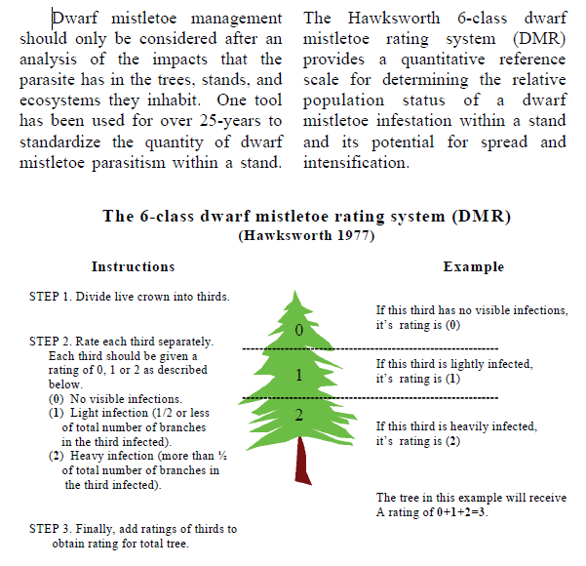
Hoffman, James T. “Management Guide for Dwarf Mistletoe”. Forest Health Protection and State Forestry Organizations, May 2004. Web.

