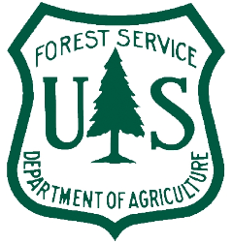
SBEADMR Field Trip 2018
Big Willow Salvage Sale, Alpine Plateau
Gunnison Ranger District
Gunnison, Uncompahgre, and Grand Mesa National Forests
Agenda
Wednesday, August 8, 2018
Depart from the Montrose Public Lands Center or Gunnison Ranger District Office (7:30 AM). Please try to be at either location by 7:15 so we can promptly leave at 7:30.
Meet up at Arrowhead Lodge (8:30 AM)
- Welcome, Introduction (Drew Stroberg)
- Risk Management: Evacuation Plan/JHA/Radio Group (Ruth Spradling)
Stop 1 (Arrive 9:30 AM)
- History/Overview of the Area (Drew Stroberg)
- SBEADMR Overview (Clay Speas)
- Spruce Beetle Landscape Ecology (Amy Lockner)
- Good Neighbor Authority (Clay Speas, Rich Edwards, Drew Stroberg)
Stop 2 (Arrive 11:15 AM)
- Aspen response to recent harvest activities/Long Draw Timber Sale (Drew Stroberg)
- Fuels/Fuel Loading (Dan Huisjen)
- Wildlife (Matt Vasquez)
- Science Team update (Jason Sibold – CSU and Mike Battaglia – RMRS)
LUNCH (12:30 PM)

Stop 3 (Arrive 1:30 PM)
- Hydro Buffers (Ashley Hom)
  - DFs: Long Draw/Old Hydrology Buffer -> SBEADMR/New Buffer differences.
- Beetles and beetle-hit tree examples (Amy Lockner)
Depart for Gunnison or Montrose (3:00 PM)

