Spruce Beetle Epidemic-Aspen Decline Management Response project on the Grand Mesa, Uncompahgre, and Gunnison National Forest (GMUG)

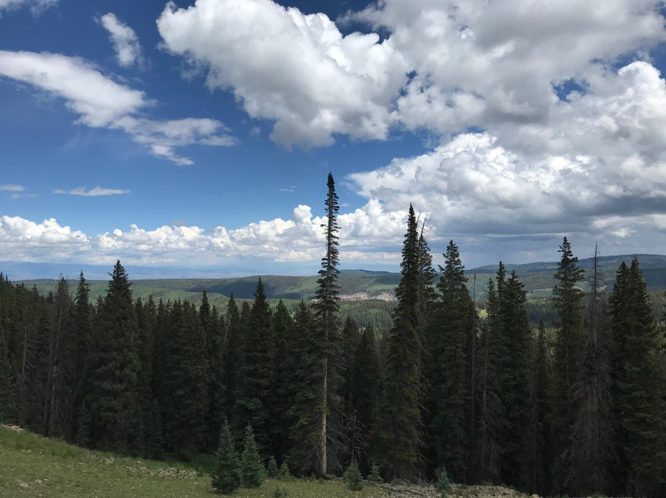

Adaptive Implementation Annual Report for 2020
Spruce Beetle Epidemic-Aspen Decline Management Response project on the Grand Mesa, Uncompahgre, and Gunnison National Forest

Adaptive Implementation Annual Report for 2020

Introduction and background

The Record of Decision (ROD) accompanying the Final Environmental Impact Statement (FEIS) for the Spruce Beetle Epidemic-Aspen Decline Management Response (SBEADMR) project commits the US Forest Service’s Grand Mesa, Uncompahgre, and Gunnison National Forest (GMUG) to utilize an adaptive implementation process through continuous public involvement:

“The Forest Service cannot significantly alter the current infestation or rate of decline in spruce stands, but management of associated hazards, economic opportunities, and resilience, as detailed in the purpose and need, are the core of this project. Nor can it accurately project the ultimate location and scale of eventual beetle activity. To achieve the purpose and need in the context of rapidly changing conditions in spruce and aspen stands across the landscape, SBEADMR relies on an adaptive implementation framework to prioritize the sequence and determine precise layout of successive treatments within the analyzed PTAs. Treatment design, incorporating additional monitoring questions, reviewing the effects of previous treatments, and adjusting management towards desired conditions and away from undesirable conditions would also be conducted via the adaptive implementation approach” (SBEADMR FEIS, Chapter 2, pp. 36-37).

Why this document?

The purpose of this report is to serve as a public record of the annual adaptive management decisions for the SBEADMR project pursuant to the FEIS and ROD. The document explicitly defines the linkages between monitoring and other applied research results, the public engagement process, and the adaptive management decisions made by the GMUG National Forest.

Who is involved?

The adaptive implementation approach involves four groups: 1) the Adaptive Management Group (AMG) originally convened by the Public Lands Partnership; 2) a “Science Team” composed of researchers from Colorado Parks and Wildlife, Colorado State University, the US Forest Service’s Rocky Mountain Research Station, and Western Colorado University; and 3) the GMUG Forest Leadership Team (FLT) composed of US Forest Service line officers vested with decision authority (e.g., forest supervisor, deputy forest supervisor, district rangers) and resource specialists.

The AMG’s purpose is to assist the GMUG National Forest in applying the adaptive management framework over a multi-year timeframe in accordance with the SBEADMR FEIS and ROD (SBEADMR Adaptive Management Group Operations Manual, version 1, June 2017). The AMG is composed of individuals representing a broad diversity of local and regional interests and perspectives regarding the SBEADMR project’s effects on ecological, economic, and social values. The AMG serves as the primary convener and coordinator of continuous public engagement.

The Science Team’s activities are supported by funds from the SBEADMR project through cooperative agreements between the GMUG and the team member’s institutions. The Science Team’s monitoring and applied research activities are based on: SBEADMR goals and desired conditions described in the FEIS and ROD, “Decision Triggers” described in Table 6, p. 44-48 in the FEIS, and additional objectives and questions defined by public stakeholders. Data collection, analysis, and reporting occurs annually.

GMUG FLT makes final decisions about changes in SBEADMR implementation utilizing a “Management Review” process. The Management Review draws on annual AMG field reviews, annual FLT field reviews with and input from GMUG resource specialists, results from the Science Team and other relevant research, and input from the AMG based on results from the Science Team and other relevant research.

What happened this year?

This table displays linkages between Goals or Decision Triggers identified in the SBEADMR Record of Decision (ROD) or Final Environmental Impact Statement (FEIS), monitoring activities and results, the SBEADMR Adaptive Management Group’s (AMG) interpretations and recommendations, and the GMUG Forest Leadership Team’s Management Review conclusions for 2020

Table 1. Goals and Decision Triggers from the SBEADMR Final Environmental Impact Statement and Record of Decision
Goal or Decision Trigger | Monitoring Actors and Activities | Results and Interpretation to Date | AMG Recommendation | FLT Management Review Conclusion | Comments
More locations from which firefighters can safely and effectively manage fires (Public Safety goal #1, ROD, p. 4) | Science Team conduct pre- and post-treatment surveys of fuel loading.  (1g.,4a) | Salvage increased fine surface fuel, decreased litter and duff fuel load. |  |  | SBEADMR EIS identified potential locations where treatments could be located to facilitate fire-fighting efforts. These data were used to help identify Priority Treatment Areas. Currently GMUG staff & partners are developing Potential Operational Delineations (PODs) to help guide placement of treatments on the landscape and to facilitate fire management efforts. PODs will be completed in 2021.
Achieve a balance of habitat structural stages, tree species composition, and seral stage distributions appropriate for each vegetation type across the GMUG (ROD Purpose & Need Desired Condition, p. 3) | Science Team field surveys of tree regeneration in unmanaged vs previously managed stands impacted by spruce beetle (1a-d, 3d.) | Abundant live trees and tree regeneration in both unmanaged and previously managed areas impacted by the spruce beetle outbreak. | Assumptions made in the EIS are still valid. No changes to SBEADMR are needed at this time. | Forest Leadership Team accepted AMG motion. No changes were made. | The spatial extent of the Science Team’s data is limited and can’t be inferred to the entire GMUG geographic area. Additional analysis using more spatially extensive data is needed (e.g., Forest Inventory & Analysis, remote sensing/LANDFIRE)
Maintain 5-15% of vegetation at the HUC 12 watershed scale in structural stages 4A, 4B and 4C where biological feasible. (Decision Trigger, FEIS, Table 6, p. 44) | GMUG NF staff updates annually based on FSVegSpatial data | In areas lacking extensive overstory mortality from beetles and other pathogens, forested watersheds are dominated by habitat structural stage 4A, 4B and 4C (large older trees). In areas with extensive overstory mortality these structural stages are lacking and will not return for several hundred years. In areas with extensive overstory mortality, WFRP-10 requires retention of live trees if they are believed to survive and removal is not needed to achieve public safety or silvicultural objectives. All Lynx Analysis Units or watersheds lacking extensive overstory mortality are expected to maintain structural stages 4A, 4B, and 4C above the 15 percent threshold. | Assumptions made in the EIS are still valid. No changes to SBEADMR are needed at this time. | Forest Leadership Team accepted AMG motion. No changes were made.
In healthier spruce-fir stands, promote regeneration and create multiple age classes (Resilience Goal 1.a., ROD, p. 4) | Science Team pre- and post-harvest surveys of forest stand structure, tree regeneration, and species composition in green treatments. (2a.) | No monitoring results to date. | No changes to SBEADMR are needed at this time. | Forest Leadership Team accepted AMG motion. No changes were made. | No green-tree spruce treatments under the SBEADMR project have been implemented to date.
Promote aspen regeneration in live stands, with emphasis on those affected by Sudden Aspen Decline (Resilience Goal 1.c., ROD, p. 4) | Science Team conduct pre- and post- treatment surveys of forest stand structure, tree regeneration, and species composition in aspen treatments | No monitoring results from the Science Team to date. However, biologists from the GMUG have reported aspen regeneration in areas containing remnant aspen stands following salvage logging. In addition, GMUG staff have initiated planning in non-commercial Priority Treatment Areas. | No changes to SBEADMR are needed at this time. | Forest Leadership Team accepted AMG motion. No changes were made. | No treatments under the SBEADMR project have been implemented to date.
Provide commercial forest products to local dependent industries at a level commensurate with the GMUG Land and Resource Management Plan direction and in harmony with other Plan goals (Recovery Goal #1, ROD, p. 4) | Science Team & GMUG staff compile and summarize timber production outputs and associated costs and revenue (5a-d) | The GMUG has ramped up timber out-puts in recent years to facilitate removal of salvage material from the landscape. Timber volume sold by fiscal year: 2017 - 69,952 CCF; 2018 - 95,377 CCF; 2019 - 93,152 CCF; 2020 – 76,302 CCF  All four years met or exceeded assigned targets, were consistent with GMUG Land Management Plan and the SBEADMR EIS. Pre-treatment Deign Checklists were completed for all treatments, design features were identified and assigned the appropriate timber sale contract clauses and provisions and implemented on the ground in accordance with the contract. | No changes to SBEADMR are needed at this time. | Forest Leadership Team accepted AMG motion. No changes were made. | Additional coordination with the science team is needed to obtain production costs and revenue.
Subsequent to salvage, treat fuels, prepare sites, and re-establish and maintain forest cover via replanting where seed sources are lacking (Recovery Goal #2, ROD, p. 4) | GMUG staff stocking surveys at 1, 3, and 5 years post-harvest.  Science Team surveys of post-salvage, unmanaged, and previously managed forest structure, tree regeneration, and species composition; seed trap collection (1b-d) | The first SBEADMR treatments were completed on the Gunnison Ranger District in 2019 and replanting was initiated in several areas. Stocking surveys will continue to ensure stands are fully stocked within 5-years of sale closure.  Science team monitoring indicates that seedling density in salvaged units similar to unmanaged and previously managed stands, and seed production is highly variable in both time and space | No changes to SBEADMR are needed at this time. | Forest Leadership Team accepted AMG motion. No changes were made. | By law, stocking surveys are required at 1, 3 and 5 years post-harvest. Within 5 years stands must be fully stocked in accordance with the Forest Plan.
Maintain soil productivity,  minimize human-caused erosion, eliminate or minimize soil damage from machine pile burning, and maintain integrity of associated ecosystems (Decision Trigger, FEIS, Table 6, pp. 44-45) | GMUG resource specialist  conduct spot inspections and post-treatment monitoring | To date, treatment design checklist have been completed for twenty-seven commercial treatments. All checklists indicate treatments are designed commensurate with this requirement. The first slash piles were burned in the winter of 2019 with rehabilitation of the burn pits occurring in 2020. Future monitoring will be conducted to determine how soils and vegetation recovers. | No changes to SBEADMR are needed at this time. | Forest Leadership Team accepted AMG motion. No changes were made.
No more than 30% of lynx habitat in a Lynx Analysis Unit (LAU) is converted to a stand initiation structural stage (>90% loss of tree overstory) due to natural or human- caused disturbance (Southern Rockies Lynx Amendment Standard VEG S1; Decision Trigger, FEIS, Table 6, pp. 44-45) | GMUG staff track structural stages in LAU annually based on FS databases (FACTs, FSVegSpatial) | In 2020 the Forest completed a project to up-date the Forest vegetation data using satellite imagery and on-the-ground vegetation plots. These data were used to up-date the amount of lynx habitat converted to unsuitable as a result of tree mortality from spruce beetle and other pathogens. The analysis indicates increased levels of habitat conversion in several LAU. Stewart Creek LAU is currently at 39%; Los Pinos is 20% and Cochetopa is 19%. No additional activity is planned in these LAU. Other than these LAU, no other LAUs have reached 20% conversion to unsuitable. The need to discontinue or modify management actions to avoid exceeding the 30% threshold is not needed at this time. | No changes to SBEADMR are needed at this time. | Forest Leadership Team accepted AMG motion. No changes were made.
No more than 3% of lynx habitat on the GMUG NF will be thinned (Decision Trigger, FEIS, Table 6, pp. 44-45) | GMUG staff track thinning activities annually in FACTS. | Forest has 42,293 acres to be used under VEG S5. Little or no thinning is anticipated under SBEADMR treatments. | No changes to SBEADMR are needed at this time. | Forest Leadership Team accepted AMG motion. No changes were made.
Wildfire and cumulative management activities will not exceed 25% of HUC12 watershed as determined by weighted acres of mechanical harvest, roads, and severe fire. (Decision Trigger, FEIS, Table 6, pp. 44-45) | GMUG staff track acres of management in FACTS and INFRA | No HUC 12 watershed has reached the 20% (yellow light trigger). The need to discontinue or modify management actions to avoid exceeding the 20% threshold is not needed at this time. One major fire did occur on the west side of the Uncompahgre Plateau in 2018. The affected watershed is outside Priority Treatment Areas identified in SBEADMR. | No changes to SBEADMR are needed at this time. | Forest Leadership Team accepted AMG motion. No changes were made.
Document that treatments are being implemented as planned; identify relevant improvements to procedures or exemplary practices to benefit future treatments (Annual IDT Treatment Review, Appendix D. FEIS) | Annual treatment review field trip with GMUG staff, subject matter specialists, and stakeholders.  Annual review of administrative processes and procedures (including SBEADMR checklist) by GMUG staff. | On 8-5-2019 a group of Forest Service specialists reviewed the High Mesa Timber sale on the Ouray RD. The purpose of the review was do determine if the treatment was conducted in compliance with the SBEADMR FEIS and associated Treatment Design Checklist. The review focused on 1) completion of the checklist and linkage to provisions of the contract; 2) adherence with specified design features and effectiveness of those design features and 3) completion of treatment specific monitoring. The team determined full evidence on six items and partial evidence on three items. No item reviewed had insufficient evidence.  On 8-15-2020 ten members of the AMG and three members of the general public visited the High Mesa Timber Sale with the Forest Service Review Team. The AMG concurred with all findings of the Review Team gave FS an average performance implementation rating of 4.5 out of 5.0. This indicates the AMG agrees or strongly agrees that the FS is implementing the project as designed.  GMUG staff recommended several changes to the Pre-Treatment Checklist in 2020 to better achieve desired conditions (Appendix A). | Recommend FLT accepts all changes to Checklist and other administrative updates. | Forest Leadership Team accepted AMG motion. The Checklist has been updated and made available to all Forest personnel as they plan 2021 treatments.
Continue the public participation and collaborative learning that occurred during the  planning phase, encourage and support the continuation of collaborative workgroup  efforts throughout implementation (FEIS Appendix E, Public Engagement in Adaptive Implementation, Goal p. 2) | Science team questionnaire and AMG participation tracking (6a-b)
Ensure implementation of treatments is responsive to dynamic on-the-ground conditions, new scientific information, and public input. (FEIS Appendix E, Public Engagement in Adaptive Implementation, Goal p. 2) | Science team questions not specifically linked to in earlier goals (1e-f.,3a-c)

Appendix A. Changes made to the SBEADMR Pre-treatment Checklist in 2020
- Range and Invasive Species Surveys – Integrated Pest Management Strategies will be used to prioritize high priority invasive weeds for treatment.
- IW-5 Design Feature modified to allow more flexibility during operations to avoid spreading weeds from weed units to non-weed units.
- SV-1 Design Feature modified to better to clarify that all regeneration cutting must comply with Forest Plan stocking requirements within 5-years of harvest.
- SP-4 Design Feature modified to clarify that slash piles must be a tee-pee shape and not in windrows. Allowances were made to allow retention of slash piles away from roads and where other objectives (e.g. fuels) could be achieved. Pile will be retained to increase levels of snowshoe hare habitat in the area.
- SP-7 Design Feature modified to eliminate placement of slash piles two tree lengths or greater from residual stands. This is impossible to implement when using resiliency treatments.
- TSHR-2 Design Feature modified to strengthen temporary road closure methods and to reduce sub-soiling from the current 8-12 inch ripping depth to 3-8 inches. These changes should significantly improve the soils ability to revegetate.
- WFRP-3 Design Feature modified to increase the amount and size of large wood retained in treatments areas. Table A-17 was added which reflects changes in best available science since the Forest Plan was signed in 1993.
- Design Feature tables were determined not to be 508 Complaint. Tables were modified to make them compliant.

Step 6 of the Adaptive Implementation Process (Appendix E of the FEIS) was modified to clarify the type of input sought from the Forest Service during the 30-day informal public comment period. Many publics were providing input regarding the analysis completed in 2016 for the FEIS. These comments are not helpful to treatment design.

Step 6 of Appendix E also requires a response to public comments. Since many of the comments are related to the structure and processes within SBEADMR it was determined to produce a list of Q&A that could be updated annually and provided to the public during the mid-winter meeting and posted on the CFRI SBEADMR website.

Contract Provisions Crosswalk – in order to better link design features from the checklist to timber sale contract provisions, GMUG staff assembled across-walk for District staff use. This improves speed and efficiency to prepare a contract and ensure design features are properly implemented on the ground.

