Resiliency in SBEADMR – Definitions and application
Carlyn Perovich, Ecologist, GMUG NF May 19, 2023
Resiliency is one of three primary project goals defined in the SBEADMR FEIS:
- Reduce threats of falling, dead trees (SAFETY)
- Improve the resiliency of stands at-risk to insects and disease (RESILIENCY)
- Treat affected stands via recovery of salvageable timber and re-establishment of desired forest conditions (RECOVERY)
As an ecological concept, it was introduced in 1973 by C.S. Holling. He defined resilience as determining the persistence of relationships within a system and as a measure of the ability of systems to absorb changes of state variables, driving variables, and parameters and still persist (i.e. avoid extinction). This is in contrast to the concept of “stability” – the ability of a system to return to an equilibrium state after a temporary disturbance. An ecosystem can be resilient, even if it is not stable.
Narrowing down from this conceptual level, the SBEADMR FEIS defines resilience as “the capacity of a system to tolerate disturbance without shifting to a qualitatively different state that is controlled by a different set of processes (Resilience Alliance 2012); i.e., the ability of a system to retain its function, structure, identity and feedbacks in the face of disturbance and environmental change (Walker et al. 2004).”
Another agency definition of resilience can be found in the 2012 USFS Planning Rule. “The ability of an ecosystem and its component parts to absorb, or recover from the effects of disturbances through preservation, restoration, or improvement of its essential structures and functions and redundancy of ecological patterns across the landscape.” This definition is similar to the one used in SBEADMR, but goes further to highlight considerations of scale in resiliency at the end of the definition: “…redundancy of ecological patterns across the landscape.”
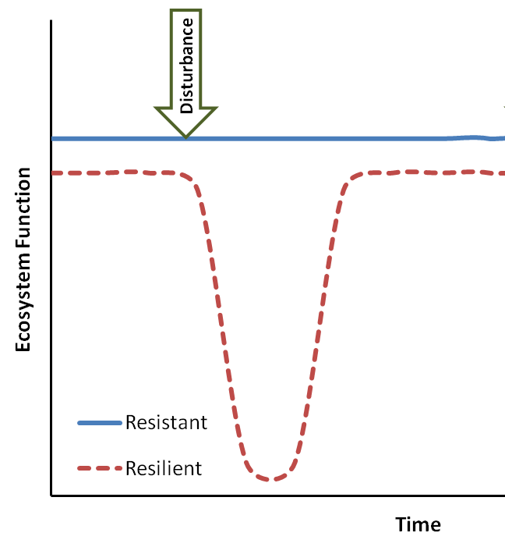
Resilience is often used as a contrasting term with “resistance”, particularly in the context of land management for a changing climate. In this framework, resistance is defined as the capacity of an ecosystem to retain its fundamental structure, processes and functioning (or remain largely unchanged) despite stresses, disturbances, or invasive species (Folke et al., 2004). Whereas resilience is defined as the capacity of an ecosystem to regain its fundamental structure, processes, and functioning despite stresses, disturbances, or invasive species (e.g., Hirota et al., 2011; Chambers et al., 2014; Seidl et al., 2016).
While the commonly used definitions of ecological resilience noted above have some small distinctions between them, they are largely in agreement on resilience as a concept. Where it can get more complicated is putting those definitions into practice. Returning to the SBEADMR FEIS, we find a forest-specific definition; “A resilient forest ecosystem is a forest that contains the diversity of composition, size, density and pattern that enables it to cope with changing disturbance processes. Such an ecosystem is capable of providing various ecosystem services such as wildlife and aquatic habitat for a variety of species, clean water, recreation, and carbon sequestration in the short and long term.” (p. 49). On p. 20 of the FEIS, the resiliency goal is broken down into three subgoals:
“1. Increase the forest’s ability to respond to multiple and interacting stresses, including climate change, insect attack, drought or disease.
a. In healthier spruce-fir stands, promote regeneration and create multiple age classes of trees.
b. Where the beetle population is endemic, minimize spread of bark beetle from infected stands to neighboring healthy stands.
c. Promote aspen regeneration via active treatments in live stands, with emphasis on those affected by Sudden Aspen Decline.”

A consistent theme in these subgoals is promoting regeneration as a means to increase resilience.
As an agency, the USFS is truly embracing the idea of resilience as a management goal. The 2022 US Forest Service Wildfire Crisis Strategy specifically calls out “Improving Resiliency in America’s Forest. However, while resilient ecosystems are worthy management goal, this paradigm can be challenging to implement in practice. There is a need to consider what types of events we want to increase resilience to – fire, insect, disease, climate change? We often defer to increasing diversity as a route to increasing resilience – but what type of diversity (species, size, age?) and at what scale?
Work from the SBEADMR Science Team is helping to address some of these questions. Some of the initial work they did looked at unmanaged and previously managed stands and effects from the current spruce beetle outbreak. Their findings indicated that previous management did not seem to increase resistance to spruce beetle, but they did find differences in seedlings (in spruce stands) and live trees/acre (in mixed spruce-aspen stands) suggesting that there may be a role for management in increasing forest resilience to spruce beetle. Ongoing work on the Rainbow and Bald timber sales is looking at impacts of SBEADMR resiliency treatments in green stands, with post-treatment results ready to share in the next few years.

References
Chambers, J. C., Miller, R. F., Board, D. I., Pyke, D. A., Roundy, B. A., Grace, J. B., ... & Tausch, R. J. (2014). Resilience and resistance of sagebrush ecosystems: implications for state and transition models and management treatments. Rangeland Ecology & Management, 67(5), 440-454.
Folke, C., Carpenter, S., Walker, B., Scheffer, M., Elmqvist, T., Gunderson, L., & Holling, C. S. (2004). Regime shifts, resilience, and biodiversity in ecosystem management. Annu. Rev. Ecol. Evol. Syst., 35, 557-581.
Hirota, M., Holmgren, M., Van Nes, E. H., & Scheffer, M. (2011). Global resilience of tropical forest and savanna to critical transitions. Science, 334(6053), 232-235.
Holling, C. S. (1973). Resilience and stability of ecological systems. Annual review of ecology and systematics, 4(1), 1-23.Resilience Alliance 2012
Resilience Alliance., Walker, B. H., S. R. Carpenter, J. Rockstrom, A.-S. Crépin, and G. D. Peterson. 2012. Drivers, "slow" variables, "fast" variables, shocks, and resilience. Ecology and Society 17(3): 30. Seidl, R., Spies, T. A., Peterson, D. L., Stephens, S. L., & Hicke, J. A. (2016). Searching for resilience: addressing the impacts of changing disturbance regimes on forest ecosystem services. Journal of applied ecology, 53(1), 120-129.
USDA Forest Service. 2016. Spruce Beetle Epidemic and Aspen Decline Management Response. Accessed at: https://www.fs.usda.gov/project/?project=42387
Walker, B., Holling, C. S., Carpenter, S. R., & Kinzig, A. (2004). Resilience, adaptability and transformability in social–ecological systems. Ecology and society, 9(2).

